26/08/2023

**PROGRAM1: To initialize array dynamically**

**Code:**

#include<stdio.h>

int main()

{

int n;

int arr[n];

int i;

printf("Enter the size of array: ");

scanf("%d",&n);

printf("\nEnter the element to be inserted in the array:");

for(i=0;i<n;i++){

scanf("%d",&arr[i]);

}

printf("\nThe array elements are:");

for(i=0;i<n;i++){

printf("%d ",arr[i]);

}

}

**Sample input & output:**

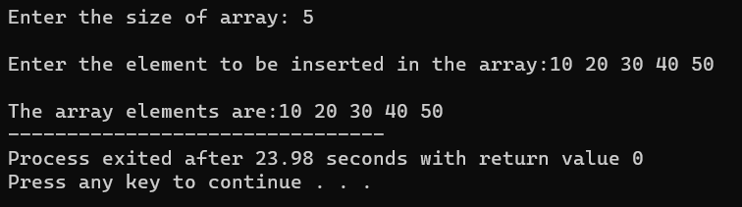

**PROGRAM2: To sum of elements in array**

**Code:**

#include<stdio.h>

int main()

{

int n,sum=0;

int arr[n];

int i;

printf("Enter the size of array: ");

scanf("%d",&n);

printf("\nEnter the element to be inserted in the array:");

for(i=0;i<n;i++){

scanf("%d",&arr[i]);

}

printf("\nThe sum of array elements is:");

for(i=0;i<n;i++){

sum=sum+arr[i];

}

printf("%d",sum);

}

**Sample input & output:**

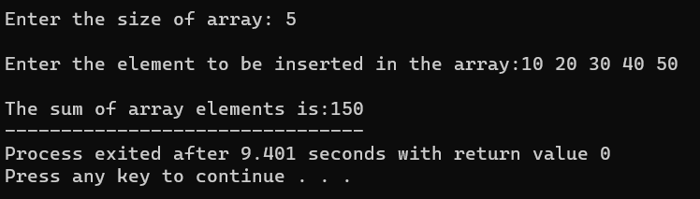

**PROGRAM3: To sum of even & odd elements in array**

**Code:**

#include<stdio.h>

int main()

{

int n,even=0,odd=0;

int arr[n];

int i;

printf("Enter the size of array: ");

scanf("%d",&n);

printf("\nEnter the element to be inserted in the array:");

for(i=0;i<n;i++){

scanf("%d",&arr[i]);

}

for(i=0;i<n;i++){

if (arr[i]%2==0){

even=even+arr[i];

}

else{

odd=odd+arr[i];

}

}

printf("\nThe sum of even numbers in the array is %d",even);

printf("\nThe sum of odd numbers in the array is %d",odd);

}

**Sample input & output:**

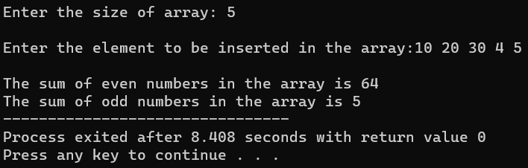

**PROGRAM4: To insert new element in array**

**Code:**

#include <stdio.h>

int main()

{

int array[50], pos, i, n, value;

printf("Enter number of elements in the array:\n");

scanf("%d", &n);

printf("Enter %d elements:\n", n);

for (i = 0; i < n; i++)

scanf("%d", &array[i]);

printf("Location to insert the new element:\n");

scanf("%d", &pos);

printf("Enter the new element:\n");

scanf("%d", &value);

for (i = n - 1; i >= pos - 1; i--)

array[i+1] = array[i];

array[pos-1] = value;

printf("The new array:\n");

for (i = 0; i <= n; i++)

printf("%d\n", array[i]);

return 0;

}

**Sample input & output:**

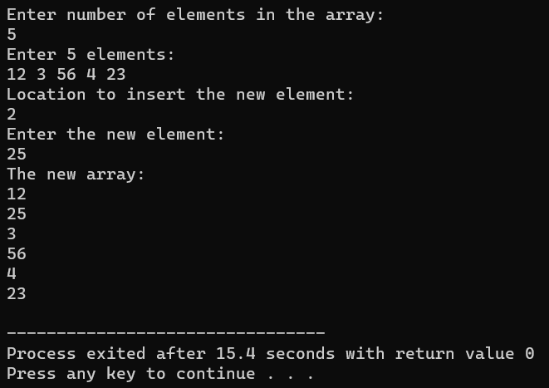

**PROGRAM5: To delete an element in array**

**Code:**

#include <stdio.h>

int main()

{

int array[100], pos, i, n;

printf("Enter number of elements in array:");

scanf("%d", &n);

printf("Enter %d elements:", n);

for ( i = 0 ; i < n ; i++ )

scanf("%d", &array[i]);

printf("Enter the location to delete element:");

scanf("%d", &pos);

if ( pos >= n+1 )

printf("Deletion not possible.\n");

else

{

for ( i = pos - 1 ; i < n - 1 ; i++ )

array[i] = array[i+1];

printf("The new array is:\n");

for( i = 0 ; i < n - 1 ; i++ )

printf("%d ", array[i]);

}

return 0;

}

**Sample input & output:**

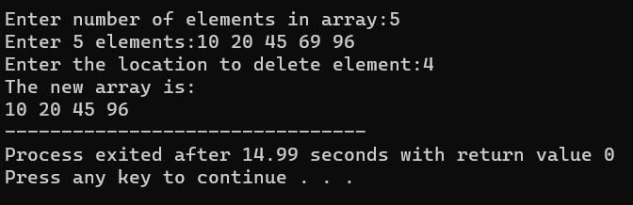

**PROGRAM6: To merge two arrays**

**Code:**

#include <stdio.h>

int main()

{

int n1,n2,n3;

int a[100], b[100], c[100];

printf("Enter the size of first array: ");

scanf("%d",&n1);

printf("Enter the array elements: ");

for(int i = 0; i < n1; i++)

scanf("%d", &a[i]);

printf("Enter the size of second array: ");

scanf("%d",&n2);

printf("Enter the array elements: ");

for(int i = 0; i < n2; i++)

scanf("%d", &b[i]);

n3 = n1 + n2;

for(int i = 0; i < n1; i++)

c[i] = a[i];

for(int i = 0; i < n2; i++)

c[i + n1] = b[i];

printf("The merged array: ");

for(int i = 0; i < n3; i++)

printf("%d ", c[i]);

}

**Sample input & output:**

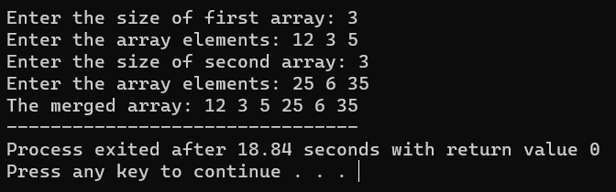

**PROGRAM7: To find duplicate elements in array**

**Code:**

#include<stdio.h>

int main()

{

int n,i,j;

int arr[n];

printf("Enter the size of array: ");

scanf("%d",&n);

printf("\nEnter the elements: ");

for(i=0;i<n;i++)

{

scanf("%d",&arr[i]);

}

for(i=0;i<n;i++)

{

for(j=i;j<n-1;j++)

{

if(arr[i]==arr[j+1])

{

printf("Number %d has duplicate values\n",arr[i]);

}

}

}

return 0;

}

**Sample input & output:**

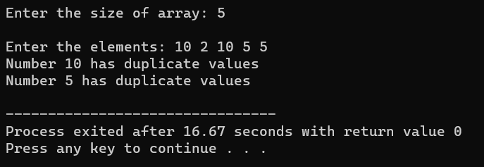

**PROGRAM8: To search an element using linear search in array**

**Code:**

#include <stdio.h>

int main()

{

int array[100], search, i, n;

printf("Enter the size of the array:");

scanf("%d", &n);

printf("Enter the elements: ", n);

for (i = 0; i < n; i++)

scanf("%d", &array[i]);

printf("Enter a number to search:");

scanf("%d", &search);

for (i = 0; i < n; i++)

{

if (array[i] == search)

{

printf("%d is present at location %d.\n", search, i+1);

break;

}

}

if (i == n)

printf("%d isn't present in the array.\n", search);

return 0;

}

**Sample input & output:**

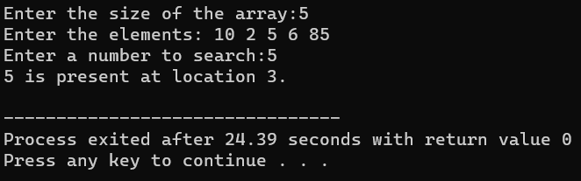

**PROGRAM9: To search an element using binary search in array**

**Code:**

#include<stdio.h>

int main()

{

int i, first, last, middle, n, search, array[100];

printf("Enter number of elements: ");

scanf("%d",&n);

printf("Enter the elements: ", n);

for ( i = 0 ; i < n ; i++ )

scanf("%d",&array[i]);

printf("Enter element to be found: ");

scanf("%d",&search);

first = 0;

last = n - 1;

middle = (first+last)/2;

while( first <= last )

{

if ( array[middle] < search )

first = middle + 1;

else if ( array[middle] == search )

{

printf("%d found at location %d.\n", search, middle+1);

break;

}

else

last = middle - 1;

middle = (first + last)/2;

}

if ( first > last )

printf("Not found! %d is not present in the list.\n", search);

return 0;

}

**Sample input & output:**

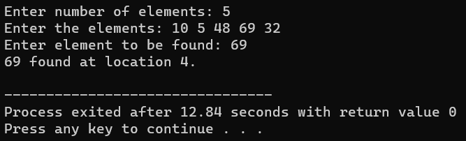

**PROGRAM10: To reverse a given string**

**Code:**

#include <stdio.h>

#include <string.h>

int main()

{

char str[100], temp;

int i = 0, j =0;

printf (" Enter a string: ");

scanf( "%s", str);

j = strlen (str) - 1;

while ( i < j)

{

temp = str[j];

str[j] = str[i];

str[i] = temp;

i++;

j--;

}

printf (" The reversed of the string: %s", str);

return 0;

}

**Sample input & output:**

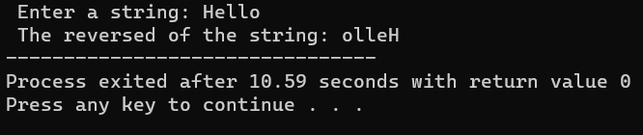

**PROGRAM11: To check if given string is palindrome**

**Code:**

#include <stdio.h>

#include <string.h>

int main(){

char str[100];

int i, len;

int flag = 0;

printf("Enter a string: ");

scanf("%s", str);

len = strlen(str);

for(i=0;i < len ;i++){

if(str[i] != str[len-i-1]){

flag = 1;

break;

}

}

if (flag) {

printf("%s is not a palindrome", str);

}

else {

printf("%s is a palindrome", str);

}

return 0;

}

**Sample input & output:**

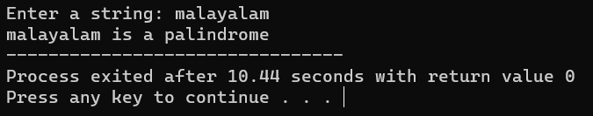

**PROGRAM12: To check & count no. of times vowels are present**

**Code:**

#include <stdio.h>

#include <string.h>

int main()

{

char str[100];

int i, vowels = 0;

printf("Enter the string: ");

scanf("%s",&str);

for(i = 0; str[i]; i++)

{

if(str[i]=='a'|| str[i]=='e'||str[i]=='i'||

str[i]=='o'|| str[i]=='u'||str[i]=='A'||

str[i]=='E'||str[i]=='I'||str[i]=='O' ||str[i]=='U')

{

vowels++;

}

}

printf("Total number of vowels: = %d",vowels);

}

**Sample input & output:**

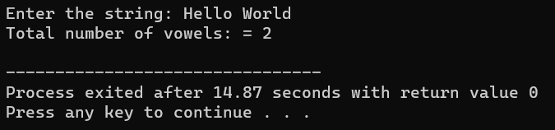

**PROGRAM13: For matrix multiplication**

**Code:**

#include <stdio.h>

int getMatrixElements(int matrix[][10], int row, int column) {

printf("\nEnter elements: \n");

for (int i = 0; i < row; ++i) {

for (int j = 0; j < column; ++j) {

printf("Enter a%d%d: ", i + 1, j + 1);

scanf("%d", &matrix[i][j]);

}

}

}

int multiplyMatrices(int first[][10],

int second[][10],

int result[][10],

int r1, int c1, int r2, int c2) {

for (int i = 0; i < r1; ++i) {

for (int j = 0; j < c2; ++j) {

result[i][j] = 0;

}

}

for (int i = 0; i < r1; ++i) {

for (int j = 0; j < c2; ++j) {

for (int k = 0; k < c1; ++k) {

result[i][j] += first[i][k] * second[k][j];

}

}

}

}

int display(int result[][10], int row, int column) {

printf("\nOutput Matrix:\n");

for (int i = 0; i < row; ++i) {

for (int j = 0; j < column; ++j) {

printf("%d ", result[i][j]);

if (j == column - 1)

printf("\n");

}

}

}

int main() {

int first[10][10], second[10][10], result[10][10], r1, c1, r2, c2;

printf("Enter rows and column for the first matrix: ");

scanf("%d %d", &r1, &c1);

printf("Enter rows and column for the second matrix: ");

scanf("%d %d", &r2, &c2);

while (c1 != r2) {

printf("Error! Enter rows and columns again.\n");

printf("Enter rows and columns for the first matrix: ");

scanf("%d%d", &r1, &c1);

printf("Enter rows and columns for the second matrix: ");

scanf("%d%d", &r2, &c2);

}

getMatrixElements(first, r1, c1);

getMatrixElements(second, r2, c2);

multiplyMatrices(first, second, result, r1, c1, r2, c2);

display(result, r1, c2);

}

**Sample input & output:**

